Docker Task – 1
Install docker on EC2 and explore the docker commands (docker images, containers, volumes, network)

1.Launch an EC2 Instance
2.Install Docker on EC2
# sudo yum update -y
# sudo yum install docker -y
# sudo systemctl start docker
# sudo systemctl enable docker
# sudo systemctl status docker
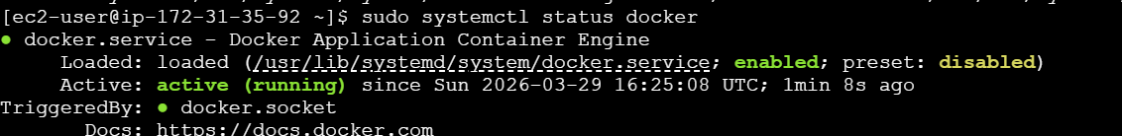
2.1. Add user to Docker group (avoid sudo every time):
# sudo usermod -aG docker ec2-user
# exit
2.2. Verify installation:
# docker –version
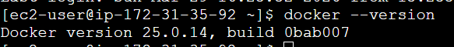
3. Run First Docker Container
# docker run hello-world
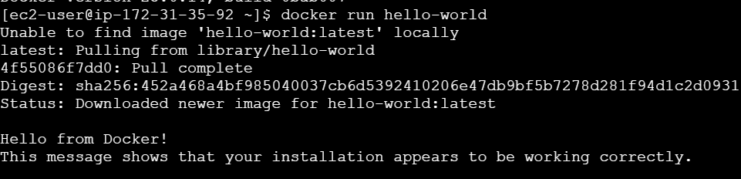
4. Docker Images Commands
4.1. List images:
# docker images
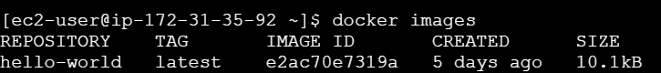
4.2. Pull an image:
# docker pull hello-world
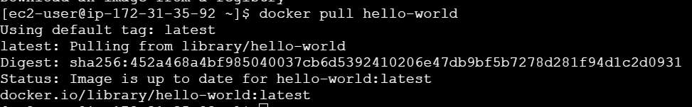
4.3. Remove image:
# docker rmi hello-world
5. Docker Containers Commands
5.1. Run container:
# docker run -d -p 80:80 hello-world
5.2. List running containers:
# docker ps
5.3. List all containers:
# docker ps -a
5.4. Remove the container using the image
# docker rm ce59a68c98ed

6. Docker Volumes
6.1. Create volume:
# docker volume create myvolume
6.2. List volumes:
# docker volume ls
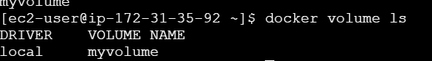
6.3. Inspect volume:
# docker volume inspect myvolume
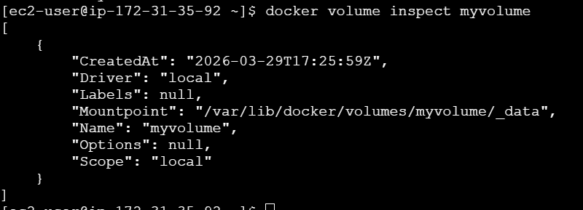
6.4. Use volume:
# docker run -d \
-p 80:80 \
-v myvolume:/usr/share/nginx/html \
Nginx
7. Docker Networks
7.1. List networks:
# docker network ls
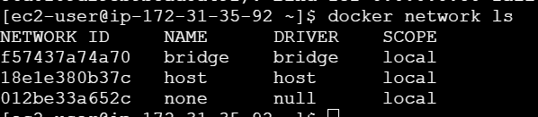
7.2. Create network:
# docker network create mynetwork
7.3. Run container in network:
# docker run -d --network mynetwork nginx
7.4. Inspect network:
# docker network inspect mynetwork
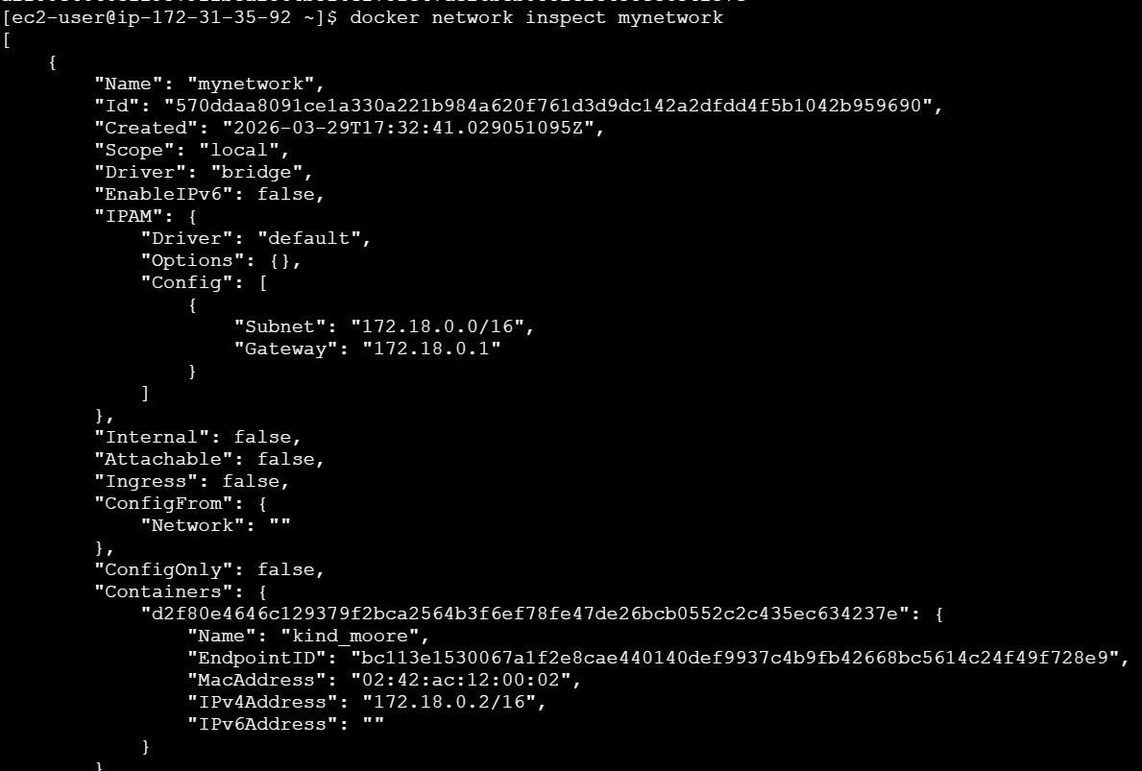

8. Useful Docker Commands
8.1.Check running processes:
# docker top 78150aaaa161
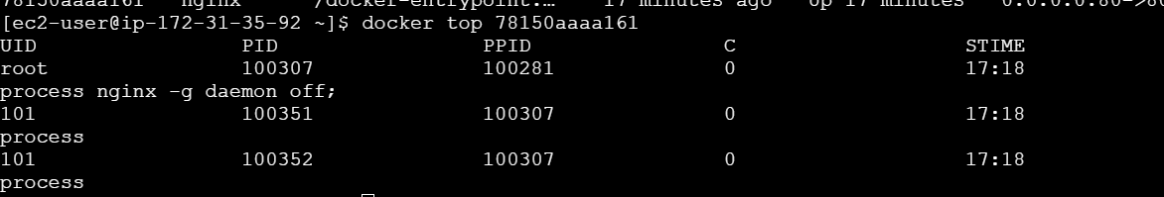
8.2. View logs:
# docker logs 78150aaaa161
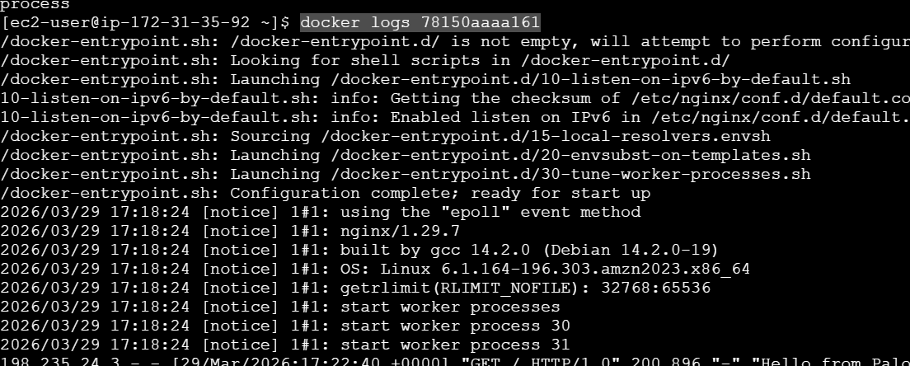
8.3. Execute command inside container:
# docker exec -it 78150aaaa161 /bin/bash
8.4. Stop all containers:
# docker stop $(docker ps -q)
9. Test in Browser
http://3.108.228.193/
